

Beddington Infants’ School

Special Educational Needs and Disability (SEND) Policy

Contents
1. Aims and Intent 2
2. Legislation and guidance 2
3. Definitions 3
4. Roles and responsibilities 4
5. SEND information report 4
6. Monitoring arrangements 5
7. Links with other policies and documents 5

1. Aims and Intent
Our SEND policy and information report aims to:
- Set out how our school will support and make provision for pupils with special educational needs (SEND)
- Explain the roles and responsibilities of everyone involved in providing for pupils with SEND

Our intent is for our children with SEND to be confident, ambitious and full members of our community with strong core skills. Our vision for our school is rooted in an understanding of, and respect for, the incredible capacity of every child.

With a focus on basic skills and strong academic achievement our curriculum has evolved to enable each child to engage at a high level and therefore to achieve to his/her personal best. Our provision is inspired by the Italian Reggio Emilia Approach. It is an experiential provision for both children and adults.
‘Tell me and I forget. Teach me and I remember. Involve me and I learn.’ Benjamin Franklin

Children:
- are respected as individuals with something valuable to say
- have a genuine input into the direction of their learning
- are empowered to engage fully with the learning process, to take personal responsibility and to develop skills for life.
- are given a variety of opportunities to explore the world in which they live, indoors and outside, developing positive attitudes to all weathers
- are supported in developing positive relationships with children and adults across the school
- are given regular, meaningful opportunities to express themselves

Our holistic approach is reflected in our aim that children leave Beddington Infants’ School with the following seven gifts:

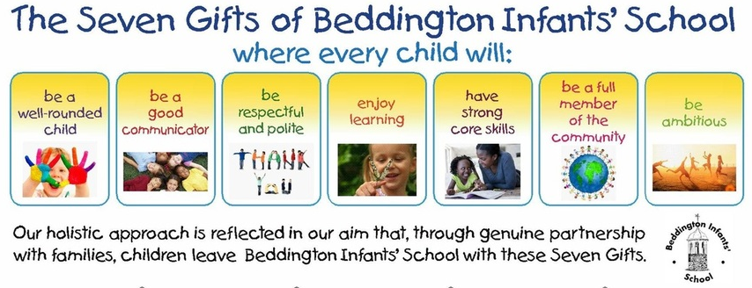

Beddington Infants’ School has historically had outstanding outcomes for the children who have attended the school. All stakeholders are constantly evaluating the provision to provide for the children additional opportunities to develop the whole child.
This school is committed to Inclusion. We aim to identify and assess children with Special Educational Needs and Disability (SEND) as early as possible, and to use our own resources and the services of outside agencies as appropriate to effectively support children’s recognised needs.

At Beddington Infants’ School, we believe that every child is an individual and that:
- educational provision will focus on helping each child to reach their potential;
- children learn at different rates and in different ways and therefore the learning experience is tailored to the individual and differentiated at the planning stage;
- we value and build on a child’s strengths;
- we are committed to helping children to develop a positive and realistic self-image and there is frequent positive involvement by adults to give feedback on work in progress;
- the views of children are given appropriate consideration;
- all children have equal access to all areas of school life through the implementation of the Equal Opportunities Policy;
- parents/carers have insights and expertise related to the child's early and ongoing experiences outside the school environment and these are valued by staff and taken into consideration when planning interventions;
- parents/carers are encouraged to be actively involved in the education of their children and in making decisions about meeting their needs;
- we make a conscious effort to provide an environment in the classroom which supports children with SEND and promotes good practice for all children;
- we provide a multi-sensory approach to teaching and learning and staff make special efforts to vary their teaching methods as children learn best in differing ways;
- once SEND is identified the school responds quickly so as to provide for the child and to give support to parents and staff.

2. Legislation and guidance
This policy and information report is based on the statutory Special Educational Needs and Disability (SENDD) Code of Practice and the following legislation:
- Part 3 of the Children and Families Act 2014, which sets out schools’ responsibilities for pupils with SEND
- The Special Educational Needs and Disability Regulations 2014, which set out schools’ responsibilities for education, health and care (EHC) plans, SEND co-ordinators (SENCOs) and the SEND information report.

3. Definitions
A pupil has SEND if they have a learning difficulty or disability which calls for special educational provision to be made for them.
They have a learning difficulty or disability if they have:
- A significantly greater difficulty in learning than the majority of the others of the same age, or
- A disability which prevents or hinders them from making use of facilities of a kind generally provided for others of the same age in mainstream schools
Special educational provision is educational or training provision that is additional to, or different from, that made generally for other children or young people of the same age by mainstream schools.

4. Roles and responsibilities
4.1 The SENCO
The SENCO is Mrs Kelly Reid, who is also the Assistant Headteacher for Inclusion.
She will:
- Work with the headteacher and SEND governor to determine the strategic development of the SEND policy and provision in the school
- Have day-to-day responsibility for the operation of this SEND policy and the co-ordination of specific provision made to support individual pupils with SEND, including those who have EHC plans
- Provide professional guidance to colleagues and work with staff, parents, and other agencies to ensure that pupils with SEND receive appropriate support and high-quality teaching
- Advise on the graduated approach to providing SEND support
- Advise on the deployment of the school’s delegated budget and other resources to meet pupils’ needs effectively
- Be the point of contact for external agencies, especially the local authority and its support services
- Liaise with potential next providers of education to ensure that the school meets its responsibilities under the Equality Act 2010 with regard to reasonable adjustments and access arrangements
- Ensure the school keeps the records of all pupils with SEND up to date
4.2 The SEND governor
The SEND governor will:
- Help to raise awareness of SEND issues at governing board meetings
- Monitor the quality and effectiveness of SEND and disability provision within the school and update the governing board on this
- Work with the headteacher and SENCO to determine the strategic development of the SEND policy and provision in the school
4.3 The headteacher
The headteacher will:
- Work with the SENCO and SEND governor to determine the strategic development of the SEND policy and provision within the school
- Have overall responsibility for the provision and progress of learners with SEND and/or a disability
4.4 Class teachers
Each class teacher is responsible for:
- The progress and development of every pupil in their class
- Working closely with any teaching assistants or specialist staff to plan and assess the impact of support and interventions and how they can be linked to classroom teaching
- Working with the SENCO to review each pupil’s progress and development and decide on any changes to provision
- Ensuring they follow this SEND policy

5. SEND information report – please see our website for this report.

6. Monitoring arrangements
This policy and information report will be reviewed by the assistant headteacher every year. It will also be updated if any changes to the information are made during the year.
It will be approved by the governing board.

7. Links with other policies and documents
This policy links to our policies on
- Accessibility Plan
- Behaviour and Welfare
- Equality
- Supporting pupils with medical needs

Last reviewed on: | 10.09.2025
Next review due by: | 10.09.2026

