Reception Curriculum Letter
Friday 17th September (weeks 4–6)
All About Me

You are welcome to come into the classroom to settle your child as long as you wear a face covering and sanitise your hands. Thank you!
Develop
We will be learning about how we grow and change and relating this to the children’s individual ages. We would like the children to bring in baby photos so that we can compare how we have changed over the years. Linked to this, we will explore the similarities and differences between our families and home lives, discussing our adults, grandparents, aunties, uncles and siblings.

Please make sure that your child has the following items in school:
- A named sun hat
- A name rain coat 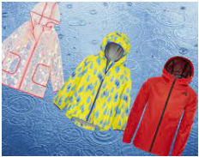

Develop  Topic  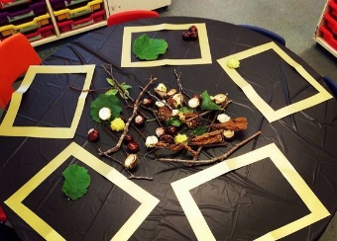 | 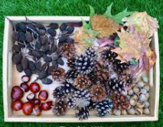  The children will be learning about the Harvest Festival, talking about how the seasons change and looking for clues to show us what Autumn is like. We would like the children to collect items such as leaves, conkers or acorns and bring them in to school for our Autumn table. We will also be learning Harvest songs and rhymes about Autumn.  In Art, we will use the Autumnal objects that we have collected to make pictures inside frames. We will also explore patterns using natural objects.  The school guinea pigs will be in the Reception central area and we will learn how to take care of them. The children will research and learn about what they need to stay healthy.
English | 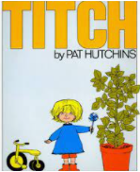  In English, we will be introducing the story ‘Titch’ by Pat Hutchins, to build a discussion about what we were like as a baby and thinking about how we change as we grow older.  During our discussions, we will be developing our skills to listen attentively and respond to what we hear with relevant questions.  We will also be building on our speaking and listening skills by talking about our family members and what makes our homes special.
Maths  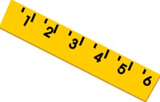 | In Maths, we will be exploring numbers 1 to 10, focusing on number order and how the numbers relate to how old the children are.  We will be using chalk to make our own large outdoor number lines on the ground and practise counting forwards and backwards.
Dates for the term | 11th – 15th October: children can bring donations for the Harvest Festival. We will provide a list of suggested items.  19th October: Harvest Festival  Inset day (school closed for children): Friday 22nd October.  HALF- TERM: Monday 25th to Friday 29th October.  END OF TERM: Friday 17th December – pick up at 1:30pm.  Please note:  The school gates open at 8.45am and close at 8.55am in the morning.  The school gates open at 3.10pm and close at 3.20pm in the afternoon.
Learning at home
- Please talk to your family members about what makes their home special.
- Please talk about how we care for our homes and what children do to help around the house e.g. tidying up
- Please continue to look for signs of Autumn on your way to school.
- Please enjoy sharing a book every day with your child and talk about your favourite stories.

Thank you, the Reception Team

